[PROJECT/CORRIDOR NAME] Social Climate Analysis
Introduction
What is a Social Climate Analysis?
While data and engineering are the crux of many traffic safety improvements, there are social and cultural factors at play as well. The Social Climate Analysis creates an opportunity for project technical staff (such as engineers and planners) to work with community members and resident leaders to identify meaningful ways to preserve community assets and to address socio-cultural barriers a proposed project might create. The recommendations generated by the Social Climate Analysis inform the overall scope, implementation timeline, and engagement strategy for the project. The Social Climate Analysis also helps to identify direct service providers, advocates, and programmatic needs that should be considered throughout and after the life of the project. A Social Climate Analysis can be used to propose many public processes including: infrastructure planning, policy proposals, and project evaluation. A Social Climate Analysis consists of three phases structured to provide past, present, and future context at the community level.
Before Phase 1, core engagement staff use a tool called the “System of Maintaining Excellence” (SME) to frame the goals and approach to the Social Climate Analysis (the SME tool can be found in the Appendixes of this document). The SME organizes perceived and researched notions of past, present, and future context. It also articulates a “bottom line”--the goals and purpose of the action/study/project/proposal. The SME is a valuable first step because it includes an assessment of tangible and structural needs associated with the action/study/project/proposal in addition to establishing best practices around regulations/agreements, creed, and standards that will inform the overall Social Climate Analysis process.
In Phase 1, core engagement staff conduct a field visit in the project area for the purposes of gathering observational data. At this phase, engagement staff have limited contact with residents within the space while documenting behavioral patterns within the space, general notions of cultural composition and interpersonal dynamics, and potential contributors to Phase 2 and 3 of the Social Climate Analysis. The analysis conducted for Phase 1 informs initial recommendations for Phase 2 contributors. Engagement staff reach out to residents, service providers, and community based organizations that either are impacted by or whose work relates to the social context deriving from the first phase.
1
Final Report Date: [DATE]
For Phase 2, residents, service providers, and community based organization accompany engagement staff for a field visit in the project area. During the field visit, non-engagement staff provide oral histories, background on community assets, and make additional recommendations for key residents and stakeholders to engage in ongoing engagement efforts. The Phase 2 field visit highlights and documents anecdotal and experiential knowledge about the project area in addition to community histories that give rise to special considerations that could be made within the final project scope, including opportunities for institutional atonement.
Phase 3 is an opportunity for project technical staff to convene with participants from the first two phases to discuss findings and to co-create solutions for problems that were documented in prior phases. This is also an opportunity for project staff to gain an appreciation for existing community values, practices, needs and assets. The goal is to preserve or enhance those assets through the planned project.
Report Contributors
The following people contributed to the Social Climate Analysis for [PROJECT NAME]:
● [NAME] - [ONE OR TWO SENTENCES DESCRIBING THE PERSON’S AFFILIATION TO THE PROJECT OR PROJECT AREA, KEY DEMOGRAPHIC INFORMATION, AND EMAIL ADDRESS]. [INDICATE ALL THAT APPLY: Phase 1 Participant, Phase 2 Participant, Phase 3 Participant, Report Contributor]
Need Statement
[REQUEST A PROJECT NEED STATEMENT FROM THE PROJECT PLANNER OR PROJECT MANAGER. THIS STATEMENT SHOULD PROVIDE A COMPLETE OVERVIEW OF WHY THIS PROJECT HAS BEEN IDENTIFIED AS A PROJECT AND IT SHOULD PROVIDE DETAILS ABOUT THE DESIRE/ANTICIPATED BENEFITS OF THE PROJECT. THIS SHOULD INCLUDE PROJECT BOUNDARIES. THE STATEMENT SHOULD ALSO INDICATE ALL CITY AGENCIES RESPONSIBLE FOR PROJECT DELIVERY AND THE COMPONENTS THAT THEY ARE RESPONSIBLE FOR. A MAP OF THE PROJECT BOUNDARIES SHOULD BE INCLUDED IN THIS SECTION ]

Social Climate Analysis:
Past, Present, and Future Context
Project Area and Community Background
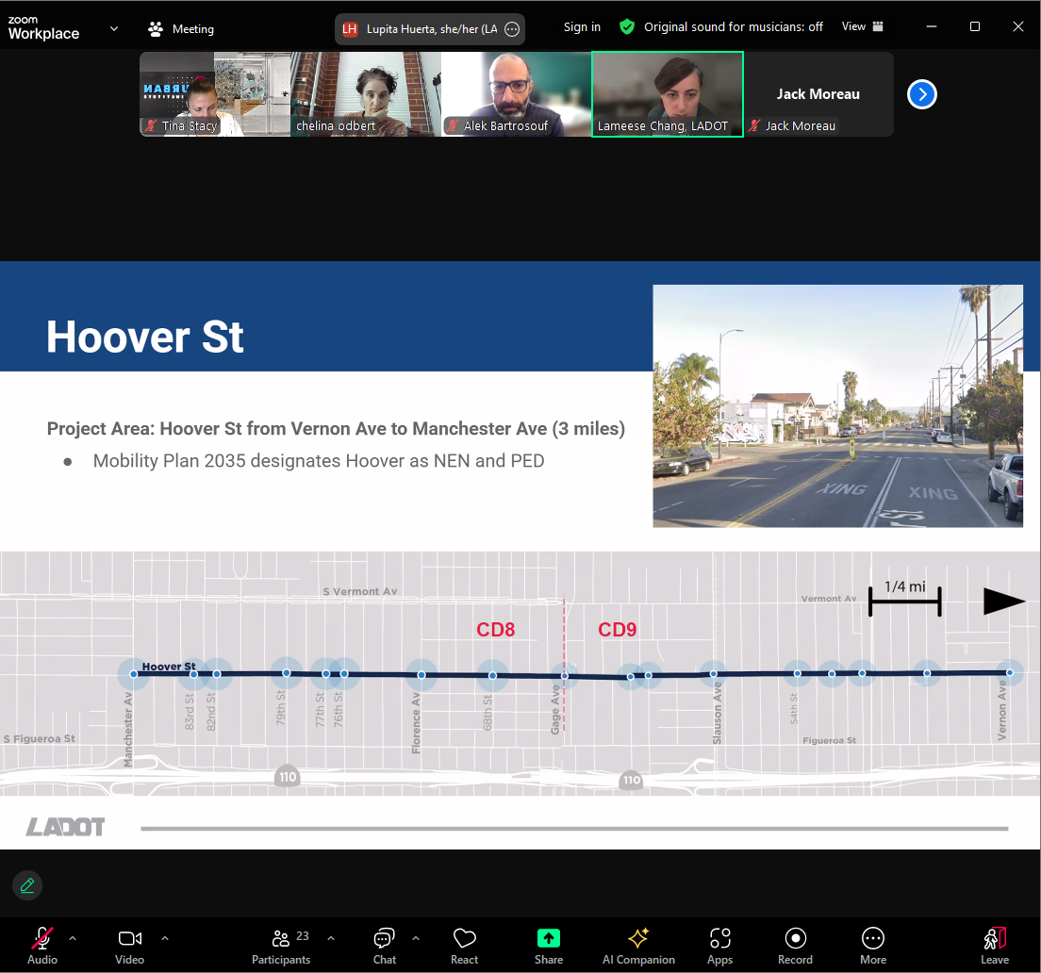
Demographics
[PROVIDE AND OVERVIEW OF THE DEMOGRAPHIC COMPOSITION OF THE PROJECT AREA. THIS SHOULD INCLUDE METRICS LIKE RACE, AGE, EMPLOYMENT RATE, LANGUAGE, WALKABILITY SCORE/DESCRIPTION, SUMMARY OF POLICE DATA IN THE PROJECT AREA, RIDERSHIP AND ORIGIN STUDY INFORMATION, GENDER DATA, ANIMAL CONTROL DATA, HOME OWNERSHIP DATA, IMMIGRATION DATA, AND ANY OTHER DATA THAT WOULD PROVIDE A COMPREHENSIVE OVERVIEW OF DOCUMENTED DEMOGRAPHICS.]
Business Analysis
[PROVIDE AND OVERVIEW OF KEY BUSINESS CHARACTERISTICS, KEY DESTINATIONS WITHIN THE PROJECT AREA]
CalEnviroScreen Analysis
[THIS SECTION SHOULD INDICATE THE CALENVIROSCREEN FOR THE AREA AND IT SHOULD BE ACCOMPANIED BY A SCREENSHOT OF THE CALENVIROSCORE MAP FOR THE AREA.]
Displacement Risk Analysis
[THIS SECTION SHOULD INCLUDE THE RESULTS OF A RENT BURDEN ANALYSIS, AN ANALYSIS OF THE NUMBER OF RESIDENTS IN THE PROJECT AREA THAT ARE HOMEOWNERS VS RENTERS, AND AN ANALYSIS OF THE NUMBER OF EXISTING VACANT OR FOR-SALE HOMES/BUSINESSES]
Infrastructure Analysis
[THIS SECTION SHOULD CONSIDER WHAT TYPES OF INFRASTRUCTURE INVESTMENTS HAVE BEEN MADE IN THE AREA IN THE LAST 5 YEARS]
Land Use Background
[THIS SECTION SHOULD PROVIDE AN OVERVIEW OF CURRENT ZONING DESIGNATIONS IN THE PROJECT AREA, EXISTING REGIONAL PLANS THAT TOUCH THE PROJECT AREA, A SUMMARY OF PLANNED DEVELOPMENT IN THE PROJECT AREA, A SUMMARY OF OTHER AGENCY PLANNING EFFORTS IN THE PROJECT AREA, AN OVERVIEW OF THE AREA PROVIDED BY THE LOCAL ECONOMIC DEVELOPMENT AGENCY, AND KEY UTILITIES INFRASTRUCTURE IN THE AREA.]
Transportation Background
[THIS SECTION SHOULD SUMMARIZE RELEVANT MODE SHARE, CRASH PATTERN DATA, INCLUDING MAPS. IT SHOULD ALSO INCLUDE TRANSIT RIDERSHIP DATA, TRAVEL TIMES, RIDE SHARE DATA, SCOOTER DATA, AND PED COUNT DATA. IF POSSIBLE, INCLUDE A SUMMARY OF RESIDENT REQUESTS SUBMITTED TO MYLADOT WITHIN THE PROJECT AREA]
Summary of Field Observations
Phase 1: Engagement Team Observations
[IN THIS SECTION, PROVIDE A SUMMARY OF PHASE 1 ENGAGEMENT STAFF OBSERVATIONS. DOCUMENT BEHAVIORAL PATTERNS WITHIN THE SPACE, GENERAL NOTIONS OF CULTURAL COMPOSITION AND INTERPERSONAL COMMUNITY DYNAMICS, AND POTENTIAL CONTRIBUTORS TO PHASE 2 AND 3 OF THE SOCIAL CLIMATE ANALYSIS. INDICATE YOUR RECOMMENDATIONS FOR PHASE 2 CONTRIBUTORS AND DISCUSS HOW YOU ARRIVED AT THESE RECOMMENDATIONS. DETAIL YOUR PROCESS FOR REACHING OUT TO RESIDENTS, SERVICE PROVIDERS, AND COMMUNITY BASED ORGANIZATIONS THAT EITHER ARE IMPACTED BY OR WHOSE WORK RELATES TO THE SOCIAL CONTEXT DERIVING FROM THE FIRST PHASE. ]
Phase 2: Engagement Team and Resident Observations
[IN THIS SECTION, ILLUSTRATE THE FINDINGS OF RESIDENTS, SERVICE PROVIDERS, AND COMMUNITY BASED ORGANIZATIONS ACCOMPANY ENGAGEMENT STAFF THAT PARTICIPATED IN PHASE 2. DOCUMENT ORAL HISTORIES, BACKGROUND ON COMMUNITY ASSETS, AND ADDITIONAL RECOMMENDATIONS FOR KEY RESIDENTS AND STAKEHOLDERS TO ENGAGE IN ONGOING ENGAGEMENT EFFORTS. BE SURE TO
4

HIGHLIGHT ANECDOTAL AND EXPERIENTIAL KNOWLEDGE ABOUT THE PROJECT AREA IN ADDITION TO COMMUNITY HISTORIES THAT GIVE RISE TO SPECIAL CONSIDERATIONS THAT COULD BE MADE WITHIN THE FINAL PROJECT SCOPE, INCLUDING OPPORTUNITIES FOR INSTITUTIONAL ATONEMENT.]
Phase 3: Engagement Team, Residents, and City/Agency Staff Observations
[IN THIS SECTION, DETAIL THE PROCESS AND OUTCOMES THAT CAME OUT OF PHASE 3 DISCUSSIONS. IDENTIFY AGREED-UPON SOLUTIONS AND PROJECT STAFF COMMITMENTS TO PRESERVING CULTURAL ASSETS AND VALUES WITHIN THE PROJECT AREA.]
Community Assets and Power Analysis
Summary of Oral Histories
[IN THIS SECTION, SUMMARIZE COMMON THEMES THAT AROSE OUT OF THE ORAL HISTORIES COLLECTED DURING THE SOCIAL CLIMATE ANALYSIS. IDENTIFY WHICH DETAILS WILL INFORM THE FINAL ENGAGEMENT STRATEGY AND SCOPE OF WORK. INCLUDE A LINK TO A PDF THAT CONTAINS ALL COLLECTED ORAL HISTORIES.]
Summary of Community Assets
[IN THIS SECTION, SUMMARIZE COMMON THEMES THAT AROSE OUT OF THE COMMUNITY ASSETS IDENTIFIED DURING THE SOCIAL CLIMATE ANALYSIS AND INDICATE WHICH COMMUNITY ASSETS WILL INFORM THE FINAL ENGAGEMENT STRATEGY AND SCOPE OF WORK. INCLUDE A LINK TO A PDF THAT CONTAINS ALL IDENTIFIED COMMUNITY ASSETS.]
Summary of Local Leaders and Key Stakeholders
[IN THIS SECTION, PROVIDE AN OVERVIEW OF THE KEY STAKEHOLDERS AND LOCAL LEADERS IDENTIFIED DURING THE SOCIAL CLIMATE ANALYSIS AND INDICATE HOW THIS PROJECT TEAM WILL INFORM AND INCLUDE THEM IN THE FINAL ENGAGEMENT STRATEGY AND SCOPE OF WORK. PASTE A SCREENSHOT OF THE CORRESPONDING POWERMAP FOR ALL INDICATED STAKEHOLDERS. INCLUDE A LINK TO A PDF THAT CONTAINS ALL IDENTIFIED KEY STAKEHOLDERS AND COMMUNITY LEADERS.]

Key Recommendations
Programmatic Recommendations
Language Justice
[IN THIS SECTION, DESCRIBE YOUR PLAN FOR ENSURING LANGUAGE JUSTICE FOR THE DURATION OF THE PROJECT. INDICATE WHICH LANGUAGES NEED TO BE CONSIDERED AND ACCOMMODATED FOR THE PROJECT.]
Accessibility and Community Dynamics
[IN THIS SECTION, DESCRIBE YOUR PLAN FOR ENSURING ACCESSIBILITY FOR THE DURATION OF THE PROJECT. INDICATE WHAT ACCESSIBILITY FACTORS NEED TO BE CONSIDERED. BE SURE TO IDENTIFY YOUR PLAN FOR CHILDCARE, TRANSPORTATION ACCESS TO IMPORTANT DISCUSSIONS AND ENGAGEMENT EVENTS, DIRECT/SOCIAL SERVICES THAT NEED TO ACCOMPANY YOUR PROJECT ACTIVITIES, COMMUNITY DYNAMICS THAT NEED TO BE MANAGED/CONSIDERED, CITY AGENCY RELATIONSHIPS AND PAST HARMS IN THE PROJECT AREA THAT MAY TRIGGER THE NEED FOR ATONEMENT OR RESTORATIVE JUSTICE. IDENTIFY YOUR PLAN FOR ENSURING THE DISABILITY COMMUNITY IS CENTERED IN DECISION-MAKING, ENGAGEMENT EFFORTS, AND PROJECT SCOPE. INCLUDE ANY ADDITIONAL ACCESSIBILITY RECOMMENDATIONS.]
Campaign Building
[INDICATE THE RANGE AND EXTENT OF PROMOTIONS, MARKETING, AND CAMPAIGN BUILDING NECESSARY FOR THE PROJECT, GIVEN THE SOCIAL CLIMATE ANALYSIS FINDINGS. ARE THERE KEY MESSAGES YOU RECOMMEND USING OR NOT USING, WHY? WHAT CONSIDERATIONS SHOULD BE MADE WHEN DEVELOPING GRAPHICS/MATERIALS FOR THE PROJECT? WHAT OTHER/EXISTING CAMPAIGNS ARE UNDERWAY REGIONALLY OR IN THE PROJECT AREA THAT COULD BE COUPLED WITH PROJECT OUTREACH?]
Approach to Engagement
Direct Service Providers to Include
The following Direct and Social Service Providers will be directly engaged through this project: ● [PROVIDE THE LIST OF DIRECT/SOCIAL SERVICE PROVIDERS WHOSE COMMITMENT/PARTNERSHIP YOU WILL SEEK. DESCRIBE YOUR REASON FOR SELECTING THEM AND DESCRIBE YOUR STRATEGY FOR ENGAGING EACH OF THEM.]
Recommended Project Partners
The following Resident Leaders, Neighborhood Councils, and Community Based Organizations will be directly engaged through this project:
● [PROVIDE THE LIST OF RESIDENT LEADERS, NEIGHBORHOOD COUNCILS AND COMMUNITY BASED ORGANIZATIONS WHOSE COMMITMENT/PARTNERSHIP YOU WILL SEEK. DESCRIBE YOUR REASON FOR SELECTING THEM AND DESCRIBE YOUR STRATEGY FOR ENGAGING EACH OF THEM.]
Business Engagement Recommendations
The following Businesses will be directly engaged through this project:
● [PROVIDE THE LIST OF BUSINESSES WHOSE COMMITMENT/PARTNERSHIP YOU WILL SEEK. DESCRIBE YOUR REASON FOR SELECTING THEM AND DESCRIBE YOUR STRATEGY FOR ENGAGING EACH OF THEM.]
Political Viability
[PROVIDE AN ANALYSIS OF THE POLITICAL VIABILITY/IMPLICATIONS OF THE PROJECT AS CONCEPTUALIZED AND PROPOSE A PLAN FOR INCREASING POLITICAL VIABILITY PRIOR TO PROJECT IMPLEMENTATION. CONSIDER WHAT STUDIES NEED TO BE COMPLETED, WHAT SURVEYS WOULD HELP ARTICULATE PUBLIC INTEREST OR DISINTEREST, AND WHAT INDIRECT COMMUNITY DYNAMICS COULD IMPACT THE POLITICAL VIABILITY OF THIS PROJECT.]
Scope and Timeline Considerations
[PROVIDE AN OVERVIEW OF ANY SCOPE AND TIMELINE CONSIDERATIONS THAT SHOULD BE MADE GIVEN THE FINDING AND ANALYSES INDICATED IN THIS REPORT.]
7

Success Metric
[LIST THREE TO FIVE MEASURABLE METRICS THAT COULD BE USED TO DEFINE SUCCESSFUL AND/OR COMPLETE ENGAGEMENT PRIOR TO PROJECT IMPLEMENTATION. THIS SECTION SHOULD BE INFORMED BY RECOMMENDATIONS AND ORAL HISTORIES INDICATED IN THIS REPORT. THINK ABOUT HOW MANY RESIDENTS/BUSINESSES YOU PLAN TO ENGAGE MEANINGFULLY, COMMON GROUND THAT COULD BE ESTABLISHED THROUGH THIS PROCESS, OR OTHER GOALS EXPRESSED BY RESIDENTS, PROJECT STAFF, AND/OR ELECTED OFFICIALS THROUGH THIS PROCESS.]
APPENDIX
Field Observation Photos
[ATTACH ALL FIELD OBSERVATION PHOTOS WITH CAPTIONS AND GEOGRAPHICALLY IDENTIFIABLE NOTATIONS]
Resident Interview Notes
[ATTACH ALL RESIDENT INTERVIEW NOTES CREATED DURING THIS SOCIAL CLIMATE ANALYSIS.]
Letters of Support for the project
[ATTACH ALL LETTERS OF SUPPORT COLLECTED DURING THIS SOCIAL CLIMATE ANALYSIS.]
Public Comments
[ATTACH ALL PUBLIC COMMENTS COLLECTED DURING THIS SOCIAL CLIMATE ANALYSIS.]

